We need you to choose your courses through completing the on-line scheduling form. This will begin your first step in your high school career.

***We are requesting that this be complete immediately.*** *If you do not choose courses, your counselor will make your course selections.*

Step 1: Scan the QR code using your phone (Open your camera or Snapchat) or use this link

 <https://cutt.ly/jtMg0jM>

Step 2: If you need to see the course descriptions, but do not have your scheduling book at home, use this link (These are the courses offered to Freshmen

 <https://cutt.ly/7tMjuwa>

You are missed! Parade!

See you on May 1 at 2:00. The parade is celebrating our love for our students!

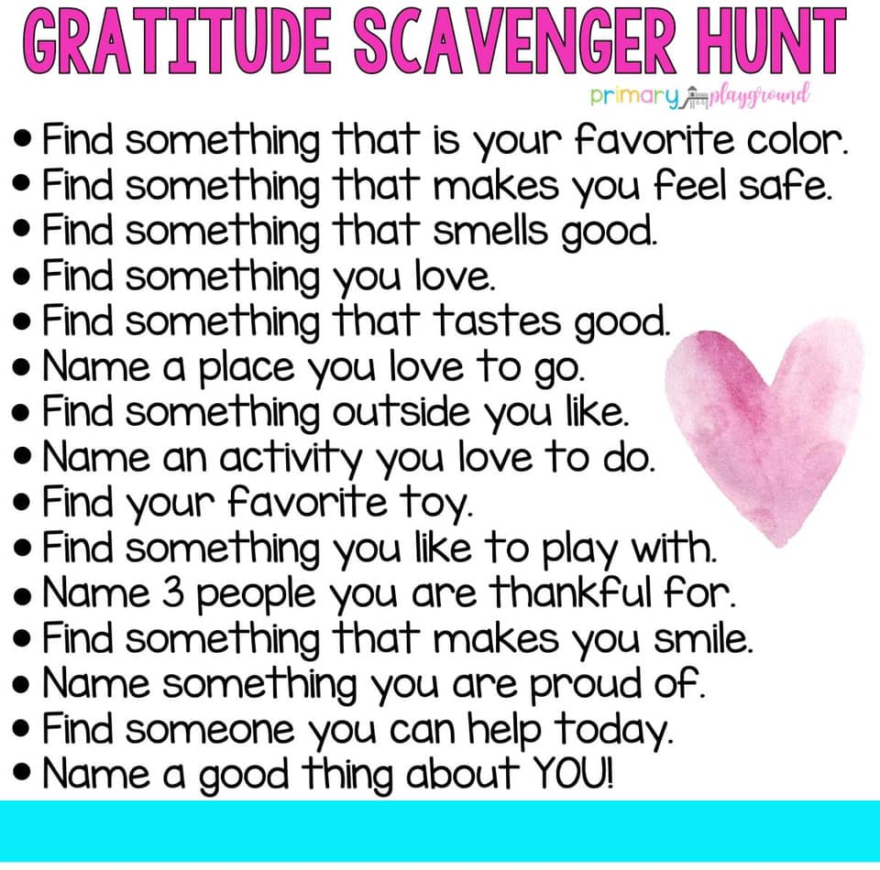

**Steps to Self-Care**

Take care of your body—get sleep, establish a routine, eat healthy, get some exercise

Connect with your support system concerning your emotions and maintaining your relationships

Take breaks and take time to do activities you enjoy

Stay informed of the updates; yet don’t get excessively focused on the news

Use technology wisely—remember to unplug

Talk to your family about your fears, emotions, and questions

Ask for help! There are moments of crisis and anxiety—you are not alone.

comfort.

**School Counselor’s Corner**

**Mrs. Goffus, Grades PK-4 (ext. 1041) and Mrs. Smith, Grades 5-8 (ext. 1119)**

**330-675-8700 - Willard PK-8 School**

**Page 2**