UPDATED Scheduling for the Class of 2024!
We are sorry that we are not getting to meet you face to face! We need you to choose your courses through completing the on-line scheduling form. This will begin your first step in your high school career.
We are requesting that this be complete by April 17, 2020. If you do not choose courses, your counselor will make your course selections.
Step 1: Scan the QR code using your phone (Open your camera or Snapchat) or use this link
https://cutt.ly/jtMg0jM
Step 2: If you need to see the course descriptions, but do not have your scheduling book at home, use this link (These are the courses offered to Freshmen)
https://cutt.ly/7tMjuwa

Step 3: If you have questions or want to contact your counselor directly, use this link.
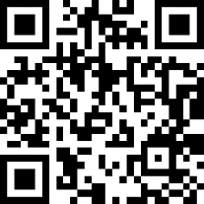 https://cutt.ly/HtMjlzCS

