Dear Kindergarten Families,
We are learning all about colors in kindergarten. For example, what letter each color word starts with, what the color words look like, and more! For the next two weeks, we will be focusing on one color per day. Please have your child dress in the color of the day. You can also have your child bring in magazine or newspaper clippings with pictures of each color. This is completely optional and is just a fun way for our students to learn the colors!
Monday September 12 – Red Day
Tuesday September 13 – Orange Day
Wednesday September 14 – Yellow Day
Thursday September 15 – Green Day
Friday September 16 – Blue Day
Monday September 19 – Purple Day
Tuesday September 20 – Black Day
Wednesday September 21 – NO SCHOOL
Thursday September 22 – White Day
Friday September 23 – Brown Day

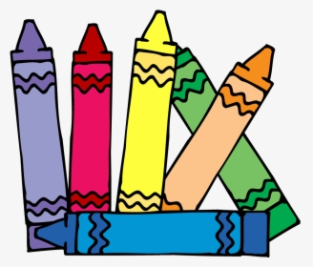
Thank you!
Kindergarten Teachers

