Turkey Dinner

On Tuesday, November 23rd, our Food Service Department will be preparing and serving a Turkey Dinner to our students to celebrate Thanksgiving.

The dinner will be Turkey Gravy, Mashed Potatoes, Cornbread with margarine, Seasoned Greens, Sweet Potatoes and Applesauce.
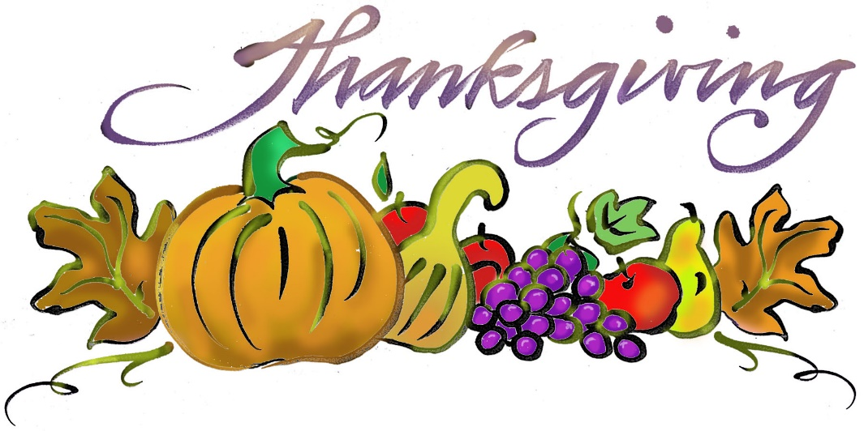

Thank you to our Food Service Department for always taking care of and feeding our children!
Happy Thanksgiving!

